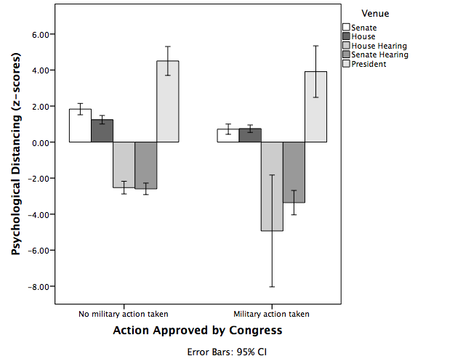

*Figure 2.* Main effect of action taken shown by venue for psychological distancing for hypothesis 1. House and Senate hearings are from specific Foreign Affairs subcommittees of each venue.